Instrument Calibration – Lab 5:

Date Performed: 03/22/2023

Lab Instructor’s name: Mark Vanpoppelen

**Honor Statement:**

An essential feature of the University of Tennessee, Knoxville, is a commitment to maintaining an atmosphere of intellectual integrity and academic honesty. As a student of the university, I pledge that I will neither knowingly give nor receive any inappropriate assistance in academic work, thus affirming my own personal commitment to honor and integrity.

I understand that inappropriate assistance includes:

* Using past lab data
* Using lab data from another section (unless approved by your instructor)
* Using the text from past lab reports
* Using text from another student’s lab report

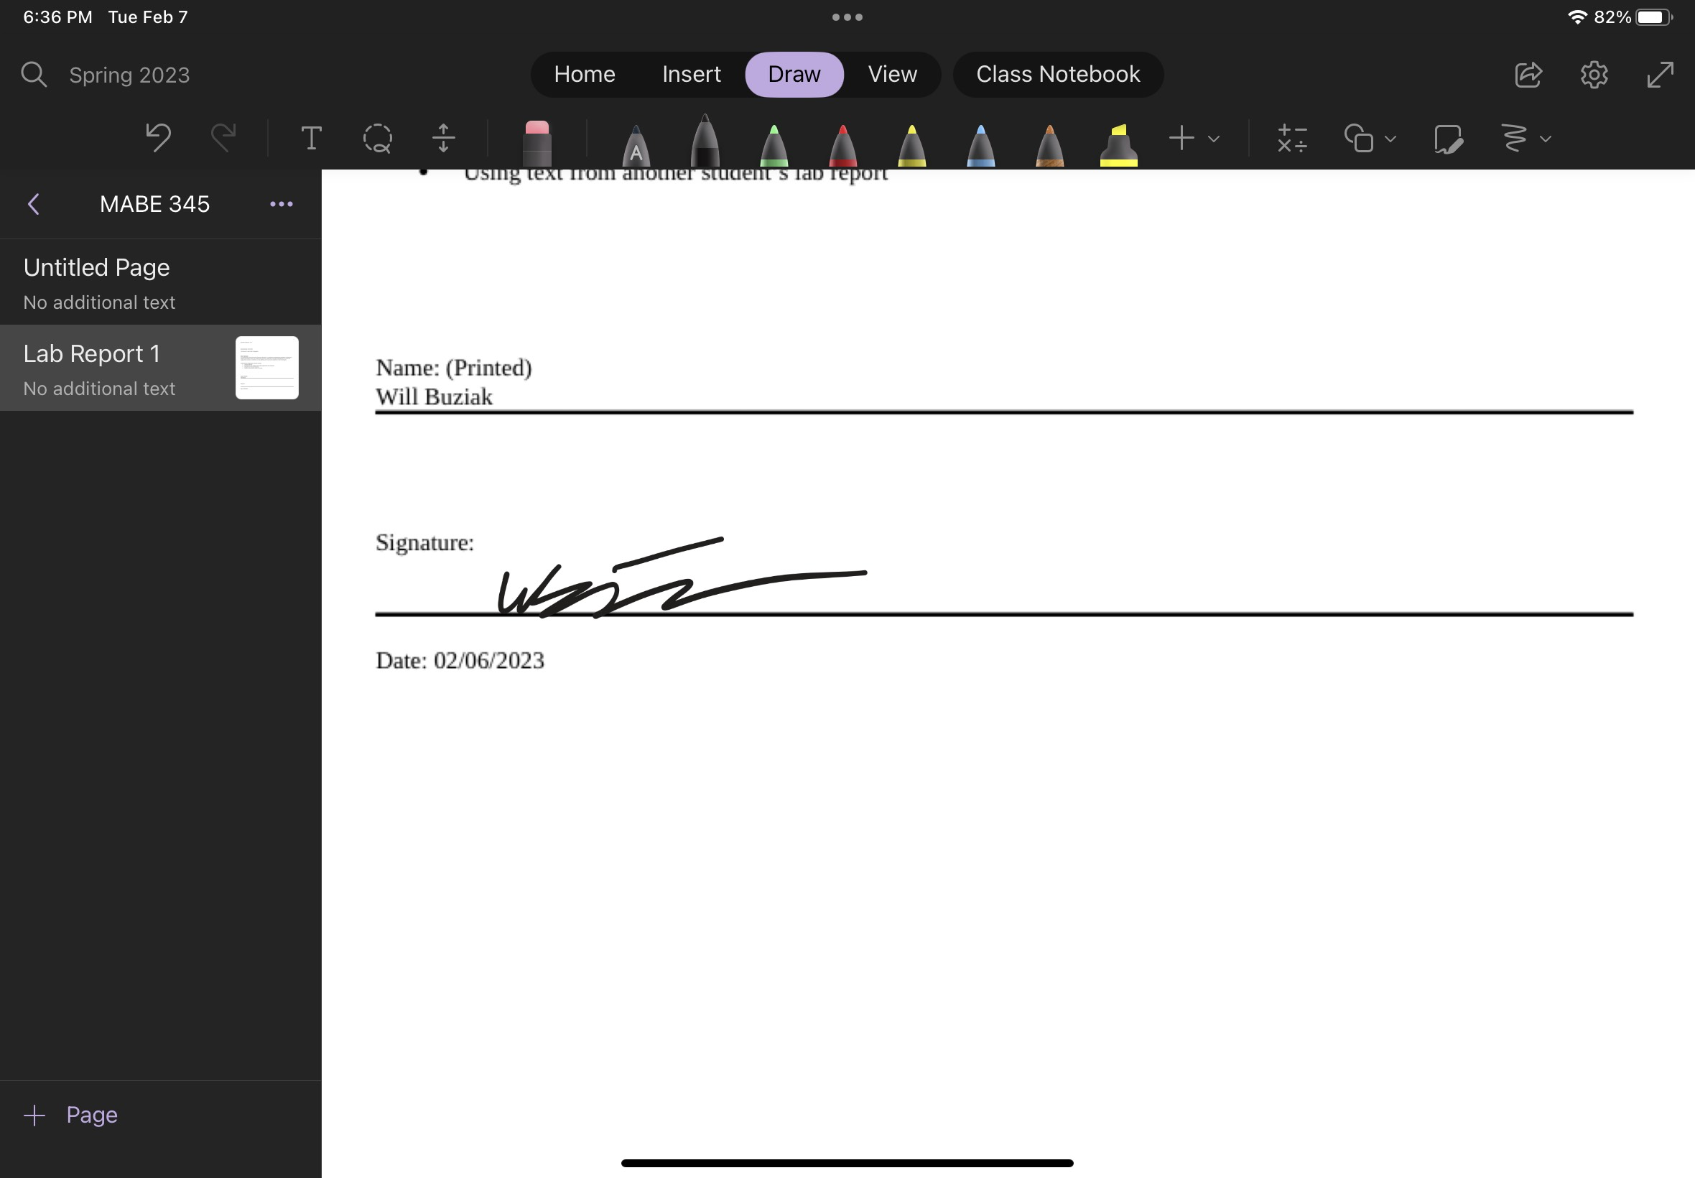

# ABSTRACT

*Will Buziak*

*(Dept. of Mechanical, Aerospace and Biomedical Engineering, University of Tennessee, Knoxville)*

Lab Report #5 – Analysis of Experimental Data

The goal of the Analysis of Experimental Data lab was to associate students with the analysis of data used in a more applied scenario than students have seen in prior labs. Previously, students were introduced to methods of measuring different phenomena in very controlled and exact processes, but what if we do not already know the behavior of the system, but only the behavior of our tools we are using to measure with? The Analysis of Experimental Data used a Matlab script in accompaniment with experimental data collected on July 8, 2020. The intent of the lab is to have the students process and analyze the data, therefore, the lab emphasized the data processing over the completion of the lab itself. Nevertheless, the experiment’s applications were arguably more tangible than past mathematical relationships that the lab’s depicted. In other words, it was a more visual and obvious process to consider when performing the mathematical processes.

# INTRODUCTION

T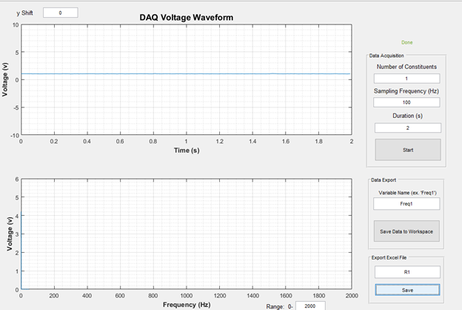he interactivity between the student and the physical system in this lab is low, utilizing the Matlab script negates the use for a real fan to measure the flow. This results in a necessity for the student to find an intuition for the relationship between

Figure 1

Initial setup

the data produced and the

expectations from what is

known about the system.

The lab sought to measure the relationships between voltage for a fan motor and the volumetric flow rate of air as a result of the spinning fan blades. The students are expected to calculate the associate linearity, hysteresis and repeatability error.

## Theory

The Analysis of Experimental Data walks the student through many different potential forms of error in an attempt to measure the volumetric flow rate of air due to a small computer fan. In many ways, the calculation of error is intended to familiarize the student conducting the lab of the many forms of inconsistencies between our mathematical model and physical representation of the system. The equations that govern the expected behavior of the system is primarily defined by equations relating the density, blade speed and cross sectional area of the fan. The basis of the theory is founded upon the displacement of air due to the spinning blades producing a a volumetric flow of air passing through a “hoop” of the same cross-sectional area as the fan. This theory is heavily reliant upon the expected density of the air and therefore will always have a large error associated with the air density as well as the temperature of the air, this will never accurately depict a real life scenario.

## Procedure

The procedure of this lab is primarily running the provided Matlab script to procure the data that was gathered on July 8, 2020. Therefore, the procedure documentation is primarily limited to running the Matlab script.

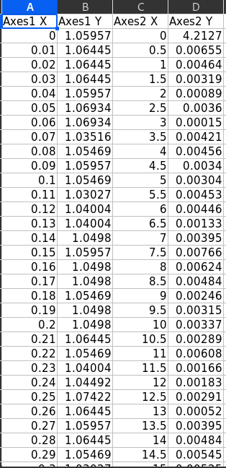

Figure 2

Data can be written directly to Excel

Begin the experiment by measuring the associated calibration errors in the equipment and measuring the temperature of the air (ambient room temperature) and use the given mathematical relationships to associate uncertainty between the air density, pressure, temperature and velocity.

The student is expected to collect the provided data for voltage during a 100Hz frequency input for 2 seconds. The voltage data can be saved and exported to Microsoft Excel.

After stepping through each iteration and collecting the required data, the experiment stage of the lab is complete and for the majority of the expected procedure, the student will be processing and analyzing the data.

The student is first expected to find the average of the voltage readings and compute a pressure differential value, this equation is provided by the transducer manufacturer and will be used to calculate the other parameter’s associated uncertainties. Next, the student will calculate the following parameter uncertainties and arrive upon an expected calculated volumetric flow rate and segmental flow rate.

## Data Reduction

Naturally, the Analysis of Experimental Data lab will include a rather expansive series of equations relative to the previous labs. The majority of these equations are finding the related uncertainty present in the model. Beyond predicting error, the equations guide the student towards calculating the necessary parameters to calculate a segmental flow rate and volumetric flow rate.



1.

Equation 1 is for bias uncertainty.



2.



3.

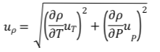

4.

Equations 2-4 are for density uncertainty. Equations 1-4 are for initial parameters and the following equations guide the student towards finding the respective flow rate uncertainties.



5.



5. A.

Equation 5 is for pressure differential value and 5. A. is standard deviation.



6.



7.

Equations 6-7 are for pressure uncertainties.

8.



9.

10.

11.

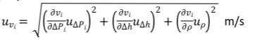

12.

Equations 8-12 are for velocity uncertainty.

13.



14.



15.

Equations 13-15 are volumetric flow uncertainty

16.

Equation 16 is segmental flow rate uncertainty.



17.

Equation 17 is volumetric flow rate.



18.

Equation 18 is uncertainty in flow rate.

19.

Finally, Equation 19 is a conversion to the percentage of the flow rate measurement.

# Results and Discussion

The final results of this lab are almost definitely skewed by an inability to calculate the standard deviation of the energy differential to solve for the standard deviation of the pressure differential. In it’s substitute, one can incorrectly use the pressure differential that was previously calculated. The logic of substituting this does not go beyond being the most recent calculation before encountering this issue for each iteration. Regardless, the following results do not often produce glaring inconsistencies until the velocity and volumetric uncertainty calculation fields. Specifically, the gradient of velocity for each iteration over the gradient of rho. Following the rest of the equations should produce a result in the neighborhood of 8.94E4 percent. This volumetric flow rate can make sense depending on the units that are referenced. For this specific case, a volumetric flow rate of 8.94E4 m^3/s would be astronomically high and in a real world scenario would cause for repeating the experiment.

# Conclusion

## Processing the data collected in an experiment is just as important as properly performing the lab when presenting findings. For example, in this instance at an important presentation in an engineer’s career, presenting uncertainties this high with a final volumetric flow rate as astronomical as this one would certainly trigger pause and potentially criticism or other unsavory results from not being more careful with data analysis.

In industry, close attention to data analysis can be catastrophic. Beyond the obvious failures that incorrect data results could produce in a product or structure that the engineer is working on, it could also produce misinformation that, if released to the public, could cause mass misinformation which has untold consequences. In other words, the data reduction and analysis performed on a lab is essential to present a sound scientific justification for findings being presented.

References

1. M. Vanpoppelen, “MABE 345 Lab Report Required Sections.docx” U.S., Knoxville, TN, 2023.
2. V. Aloi. (2023, February). ME/AE/BME 345 Instrumentation and Measurements class notes. [Online]. Available e-mail: valoi@utk.edu

Appendix A: Equipment Information

1. Lab computer (Matlab)



Appendix B: Matlab Calculations

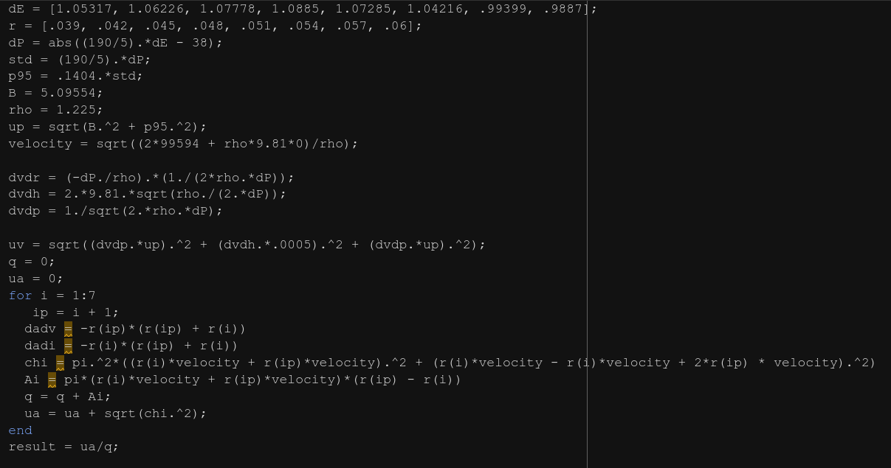

Appendix C: Complete Data Sheet (data continued on hand written sheet)

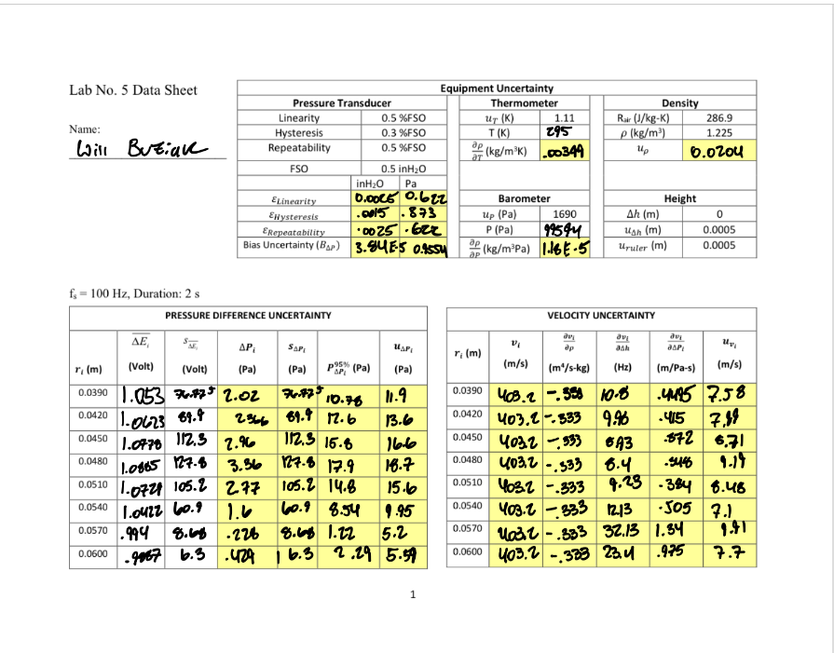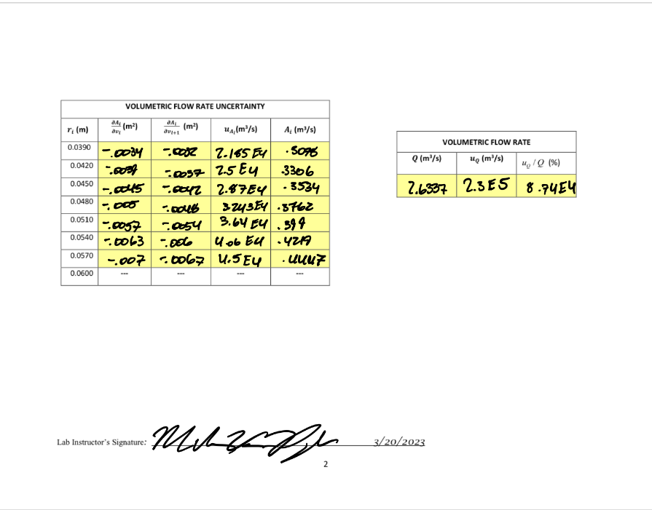

A

Figure C

Experiment 2.

Zero Mass Measurements

Figure F

Instructor Signature